7.2A – 1 (S) two Z
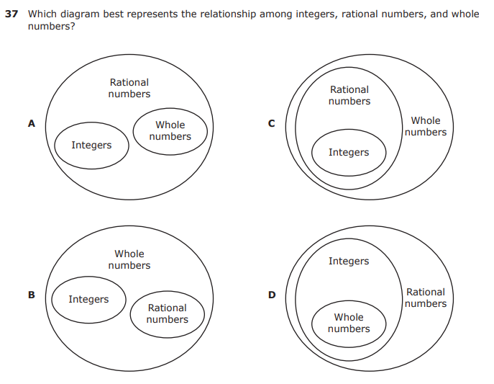
7.3A – 2 (S) five -19.8
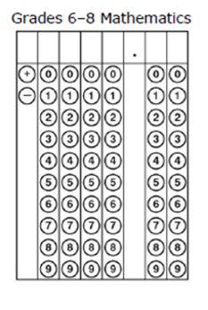
7.4C – 2 (S) eight Z
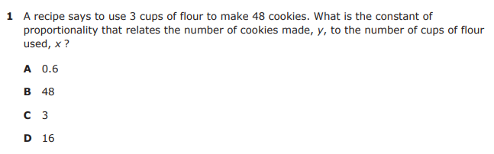

7.4E – 3 (S.) eleven W
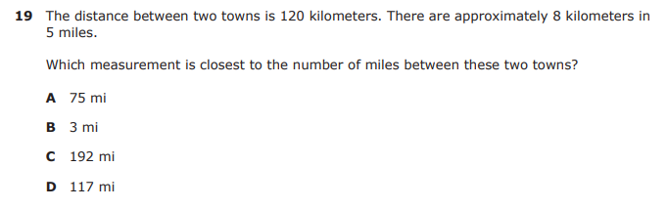

7.5A – 3 (S.) fourteen X
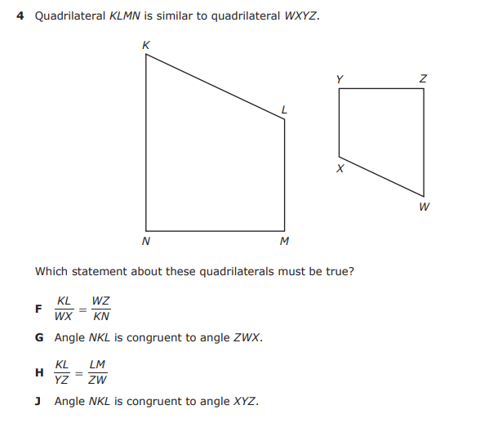

7.5B– 3 (S.) fifteen X
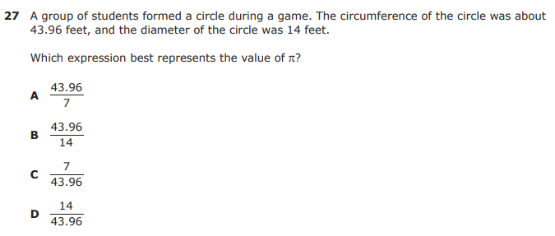

7.6A – 1 (S.) sixteen Y
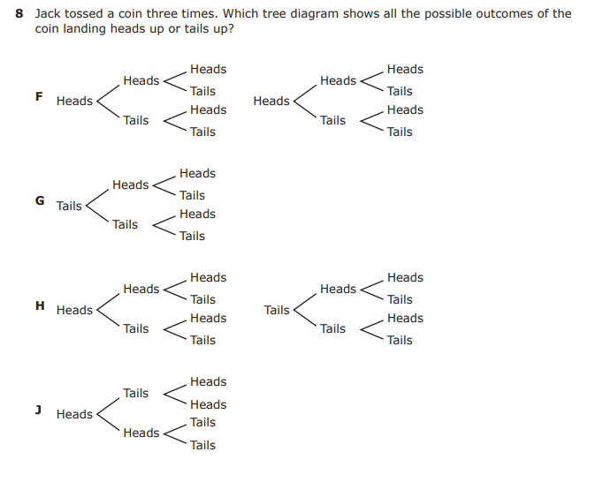
7.10B – 2 (S) thirty one X
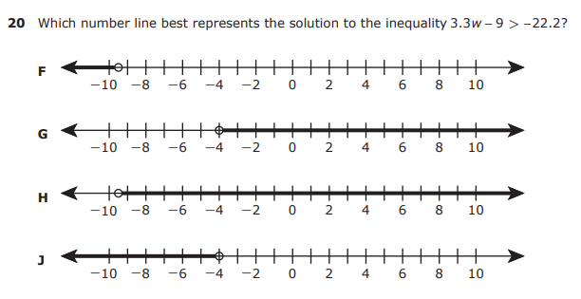

7.10C – 2 (S) thirty three X
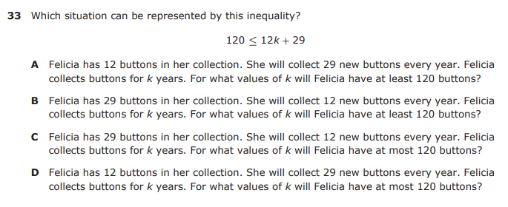

7.11B – 2 (S) thirty six Y
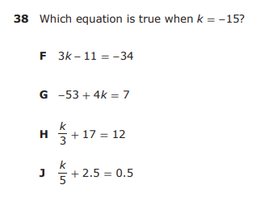

7.11C – 3 (S) thirty seven 5
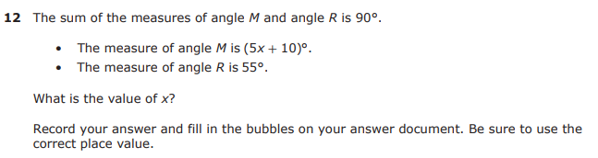
7.12B – 4 (S) thirty eight Y
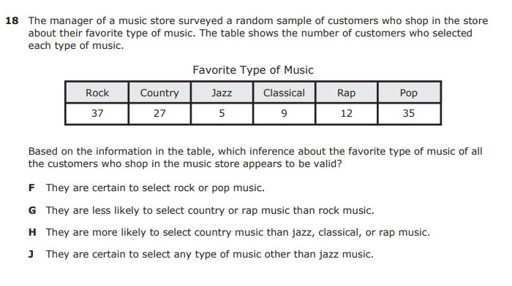

7.13A – 4 (S) forty 1.92
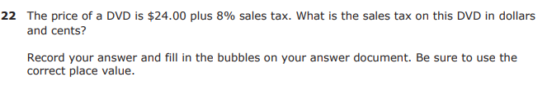
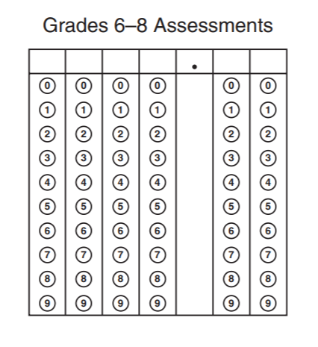
7.13C – 4 (S) forty two Y
